|  |
| --- |
|  |
| Vaccination management system:  Batch code;  2301B3  ***SEMESTER 2 (DISM);*** |

* **TEAM MEMBERS DETAILS:**

**MEMBERS NAME:**

**1.NIHA SIDDIQUI (**Student1452432**)**

**2.MEHREEN FAIZ (**Student1452437**)**

**3.** **MUHAMMAD UBAID (** Student1452442**)**

**SUBMITTED TO:**

**eProjects@aglsm.com**

**PROJECT INSTRUCTOR:**

**WALI MUHAMMAD**

**CURRICULUM CODE:**

**7062**

# TABLE OF CONTENT;

E-PROJECT

INTRODUCTION TO CELLINFO 5

REQUIRMENT SPECIFICATION 5

(A) HARDWARE REQUIRMENT 5

(B) SOFTWARE REQUIRMENT 5

SITE DEFINATION

* HOME
* ABOUT
* SERVICES
* VACCINATION
* TEAM
* CONTACT

2.PORTALS;

* DASHBOARD
* HOSPITAL
* PARENT

# SITE DETAIL SNAPSHOTS;

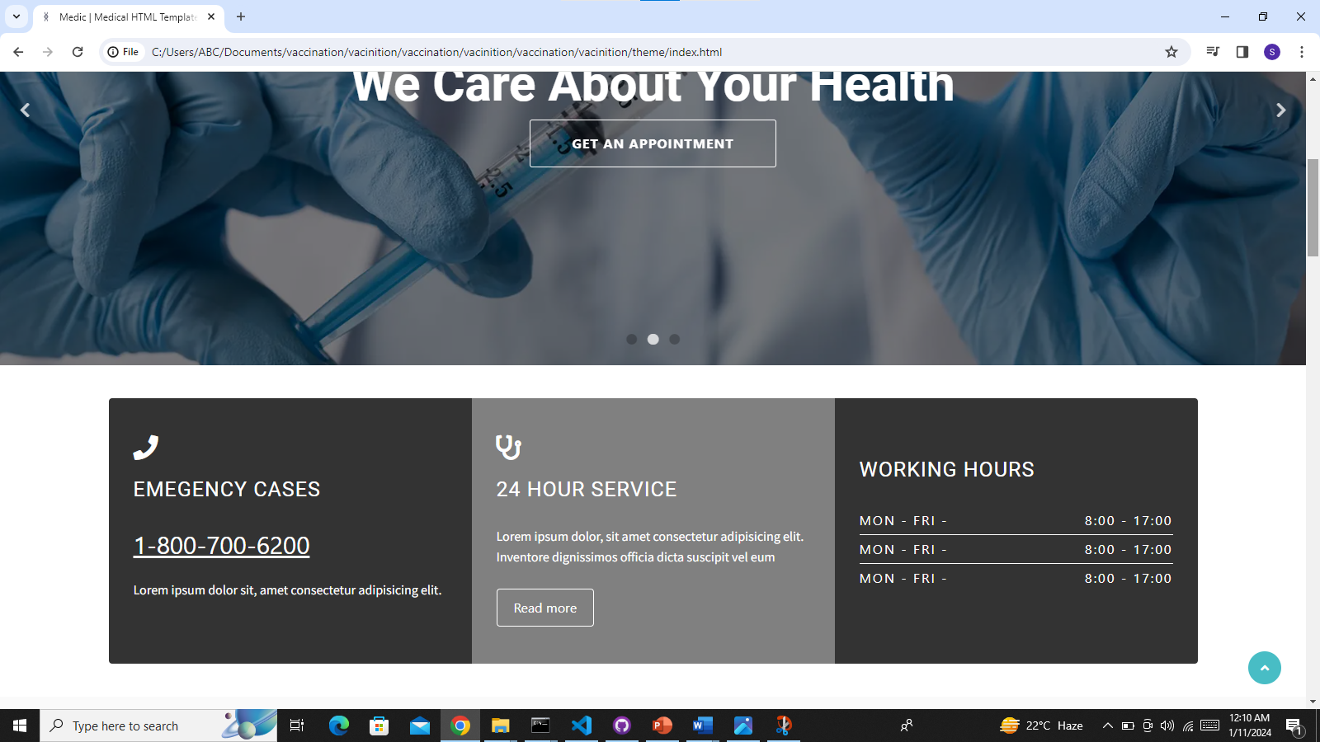

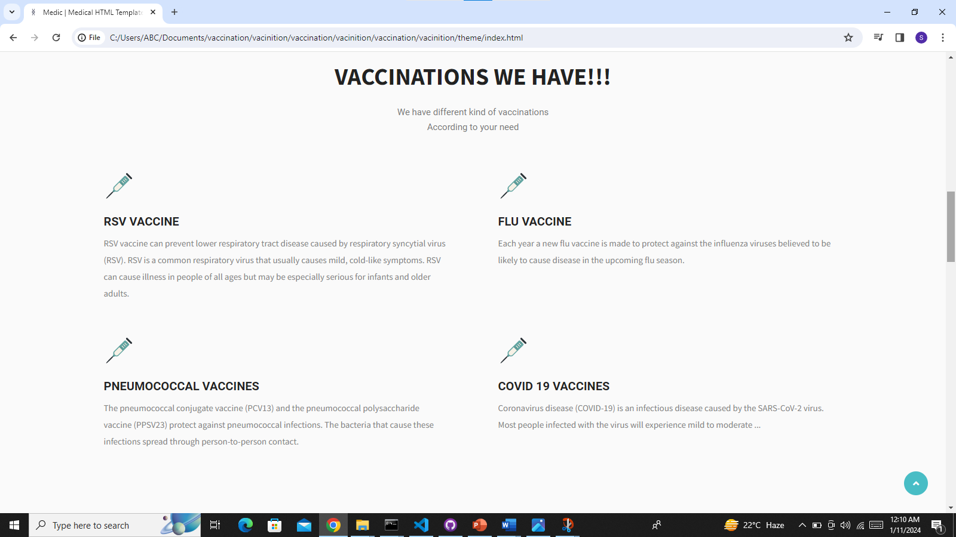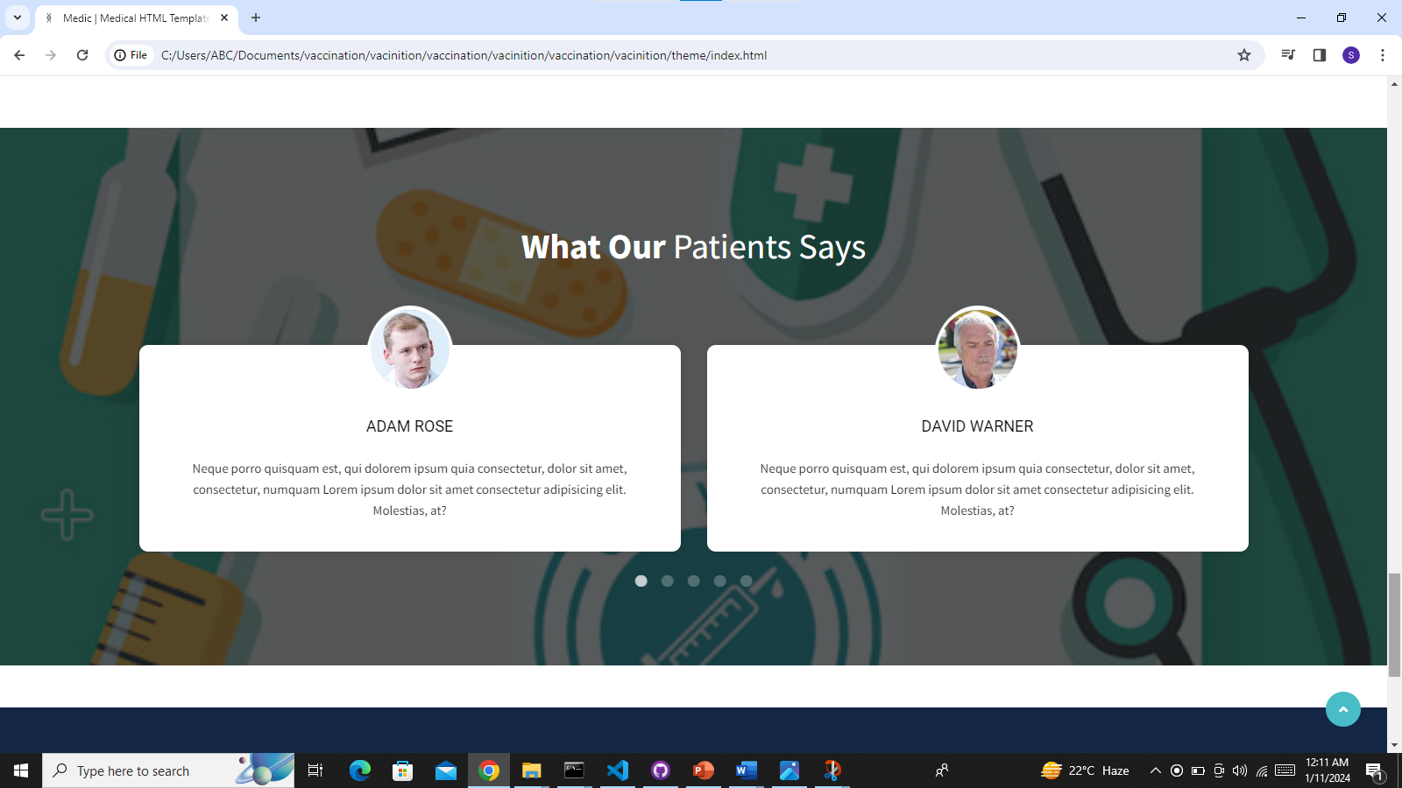

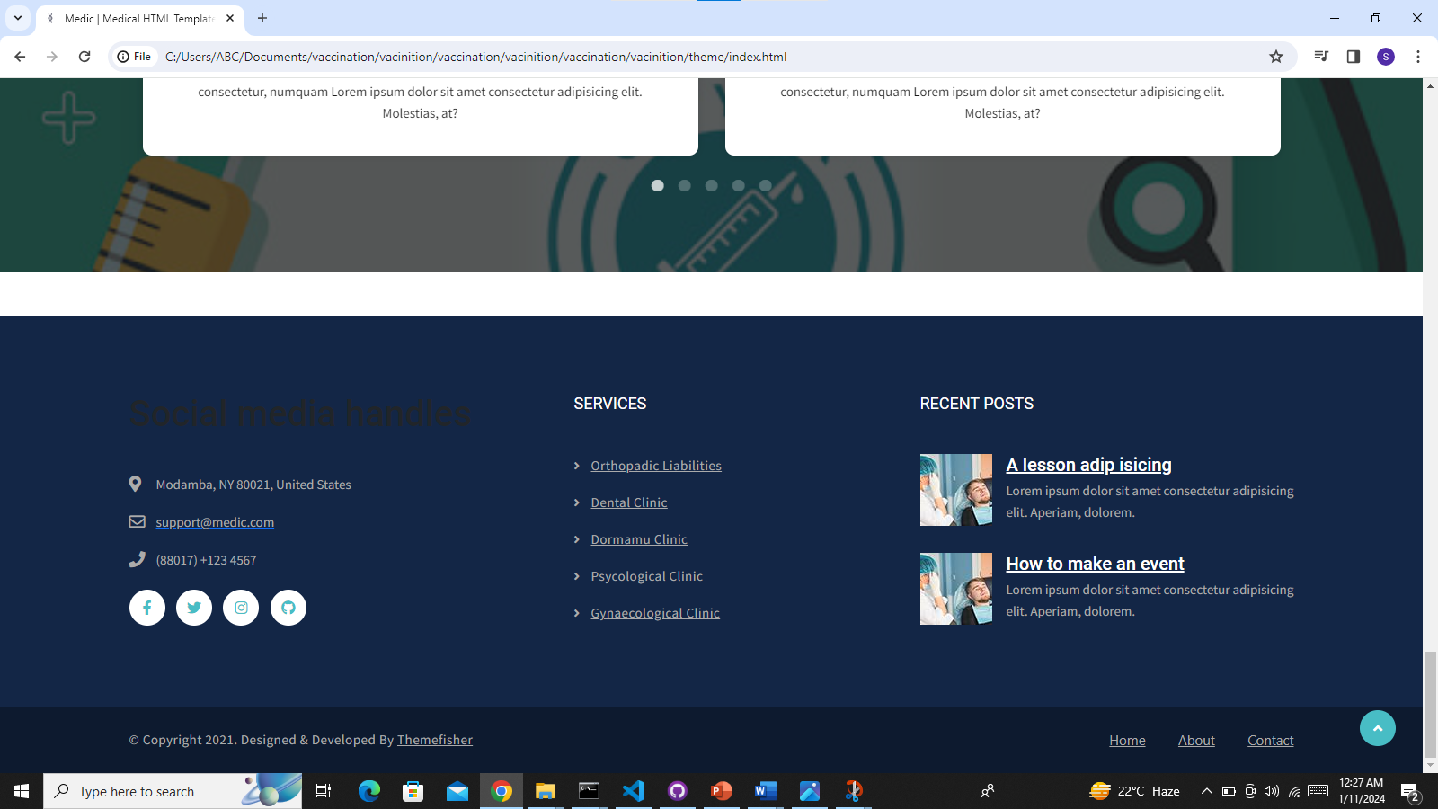

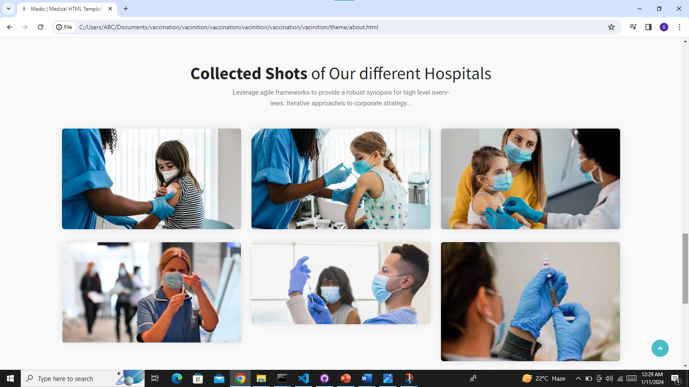

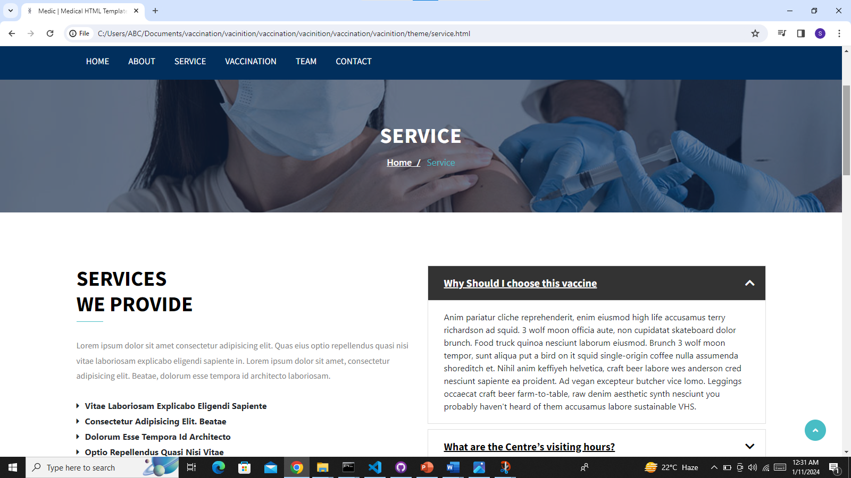

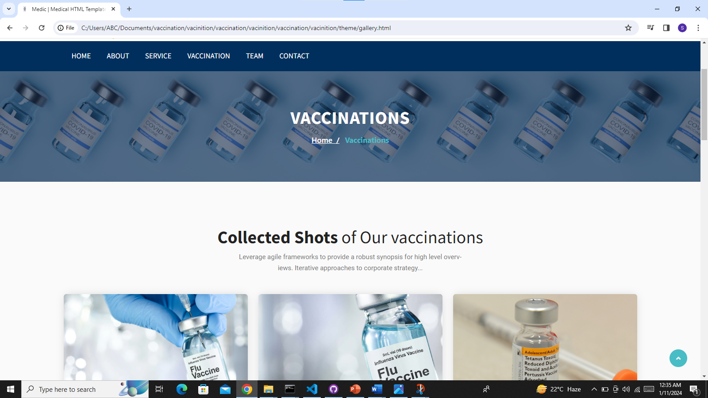

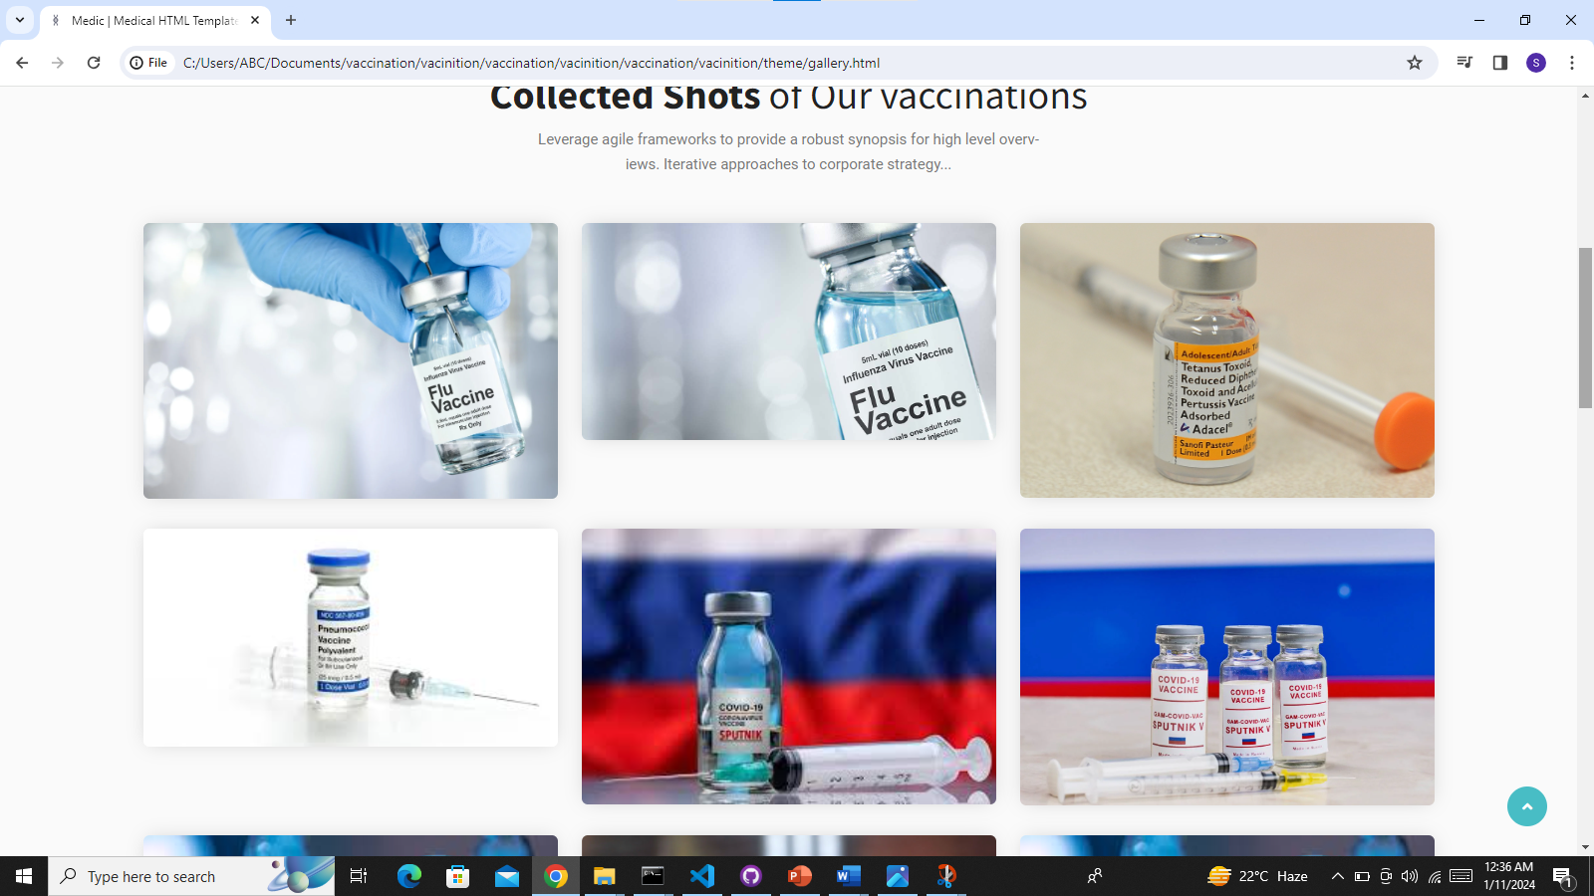

|  |
| --- |
|  |

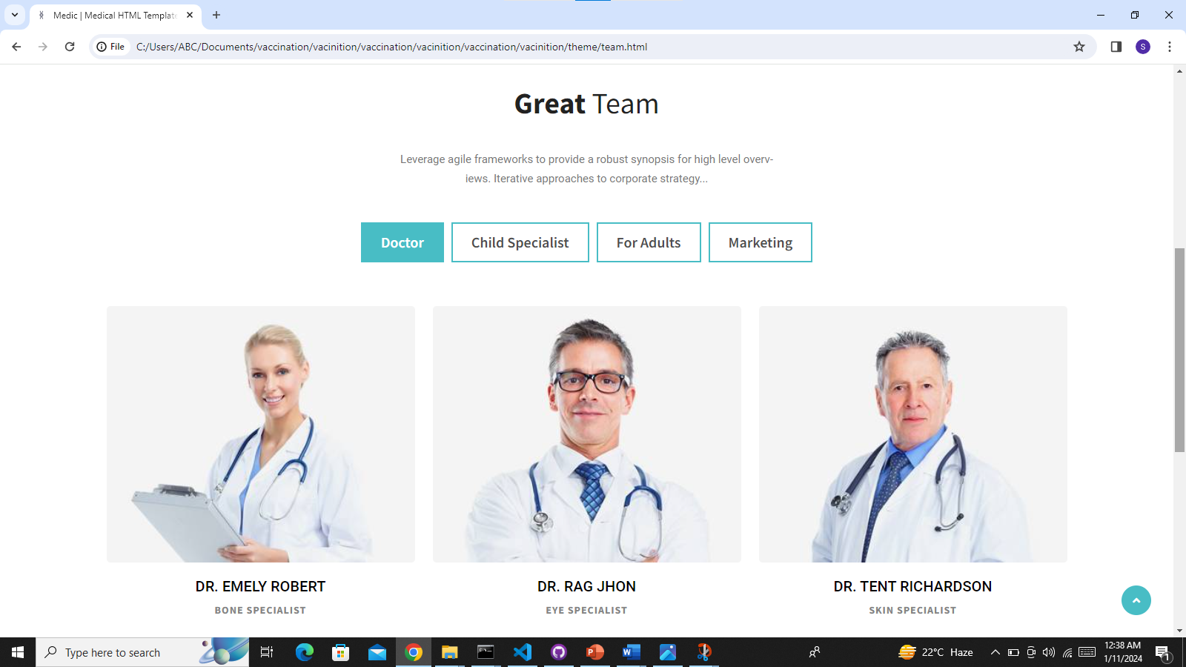

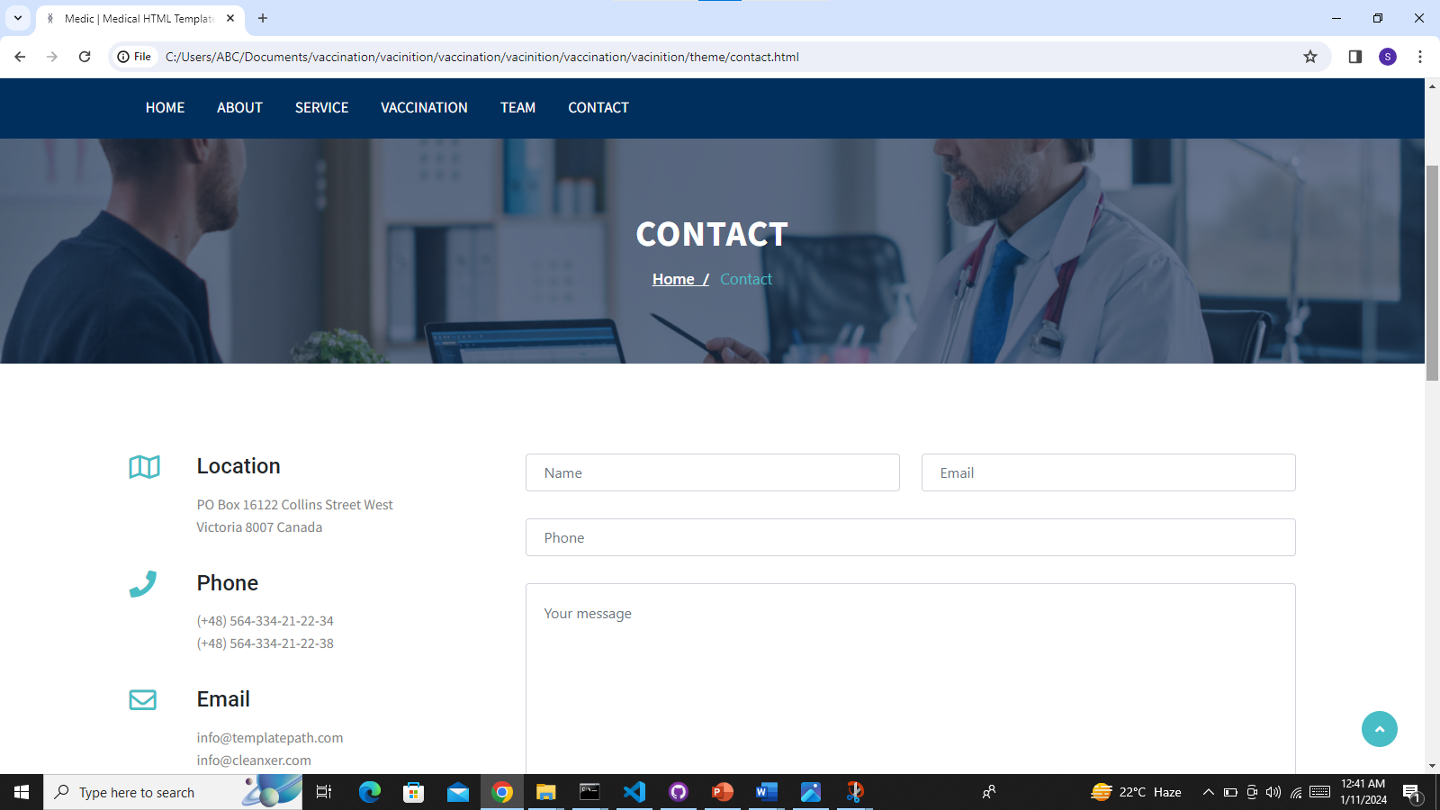

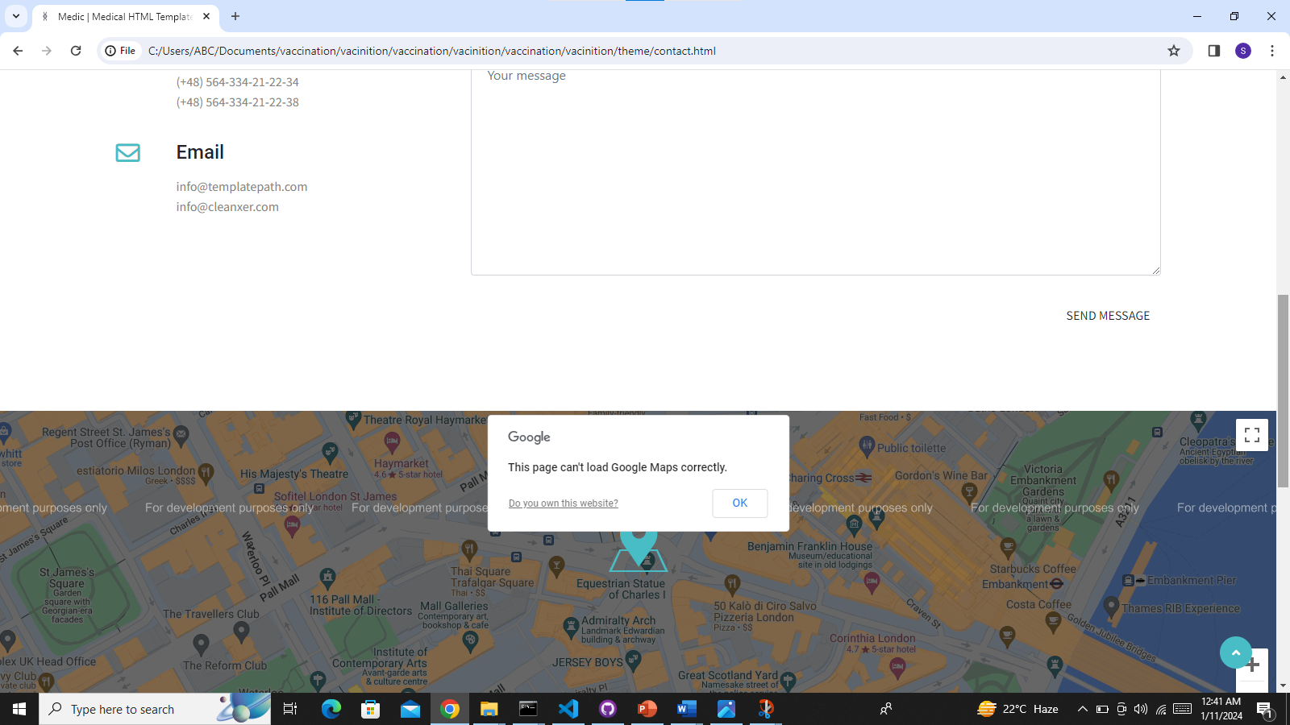

**Snapshots of portals;**

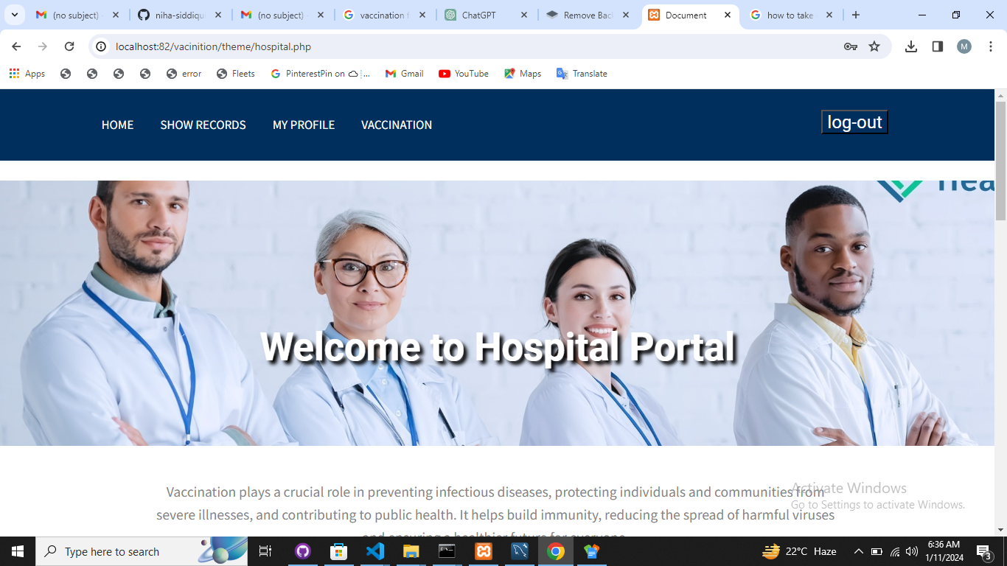

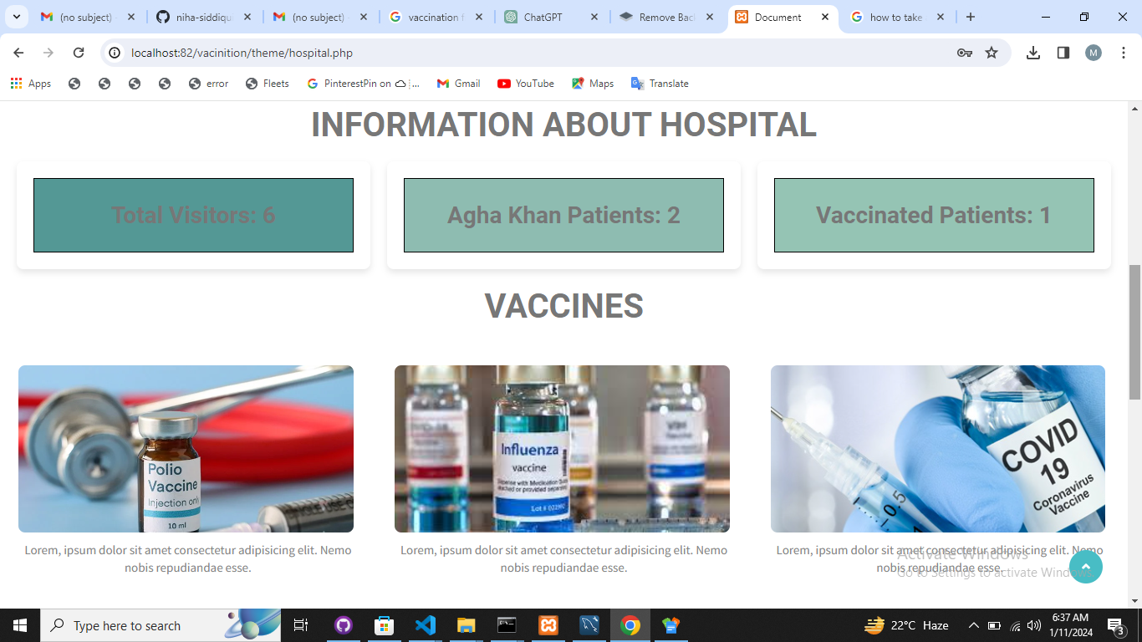

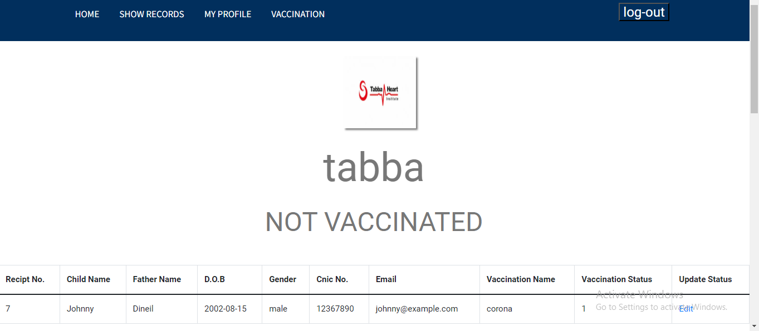

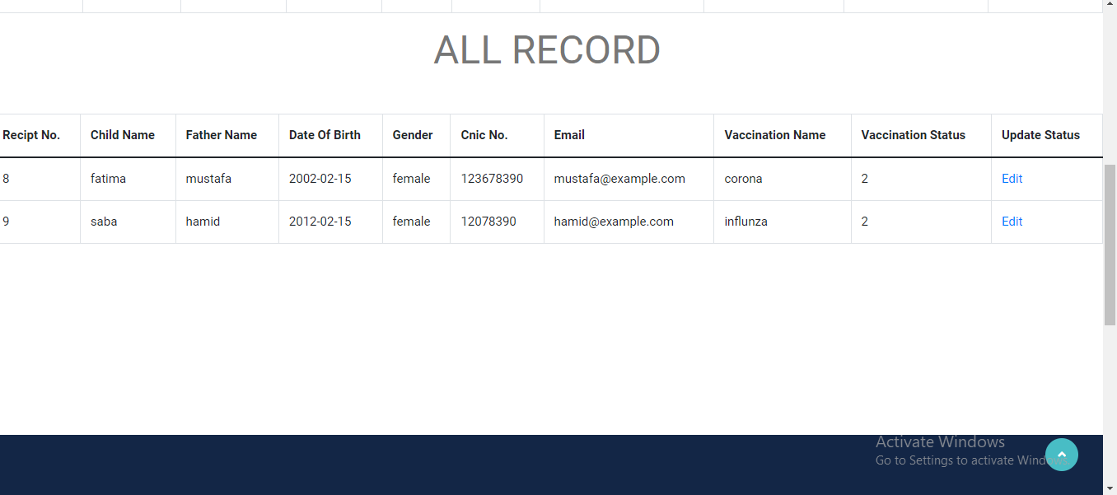

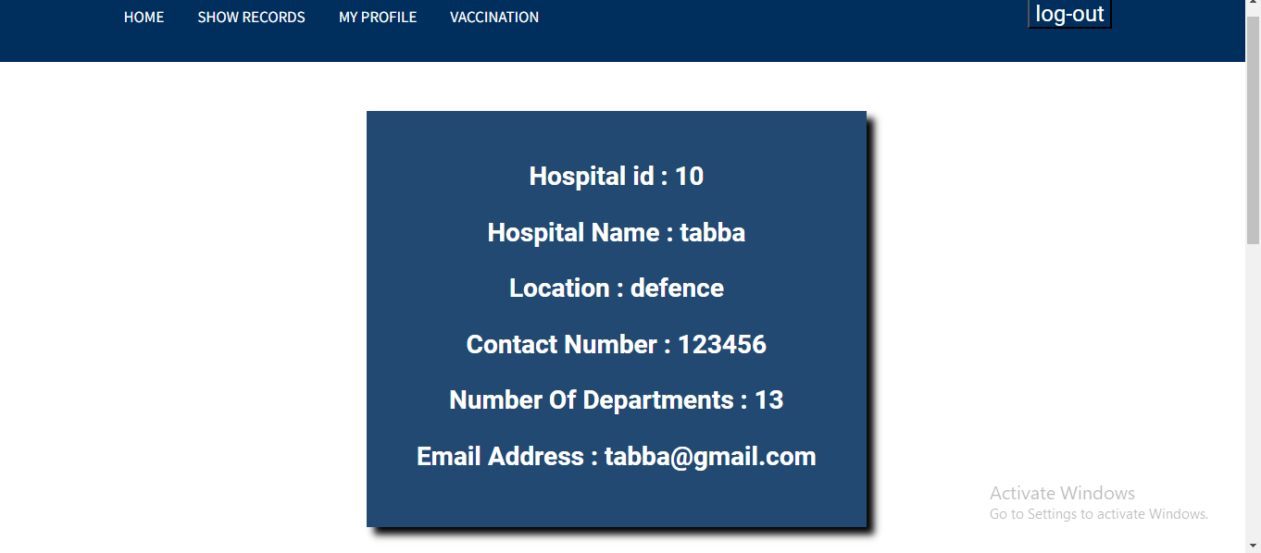

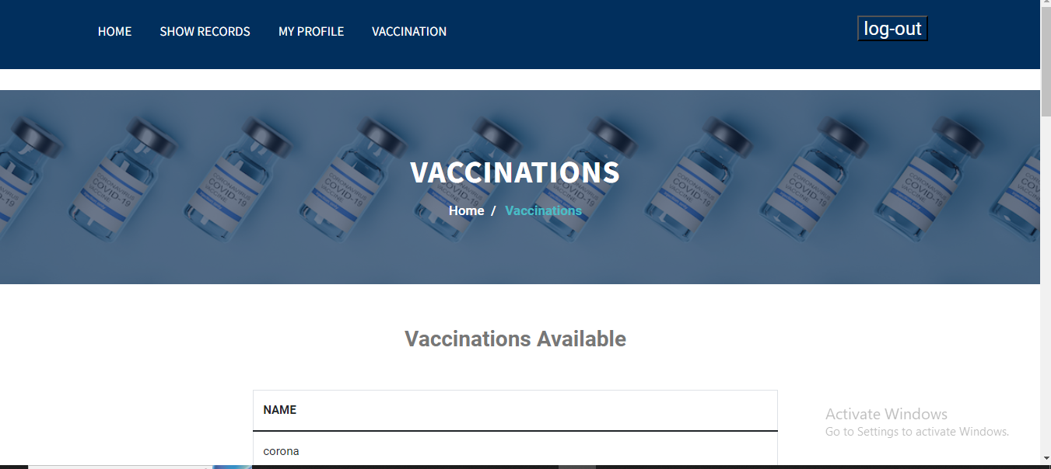

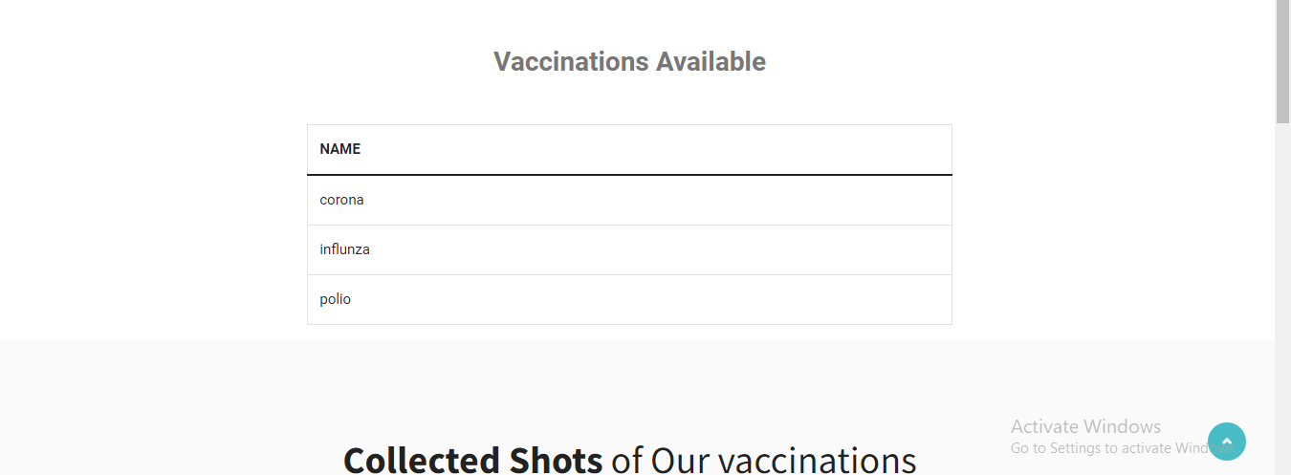

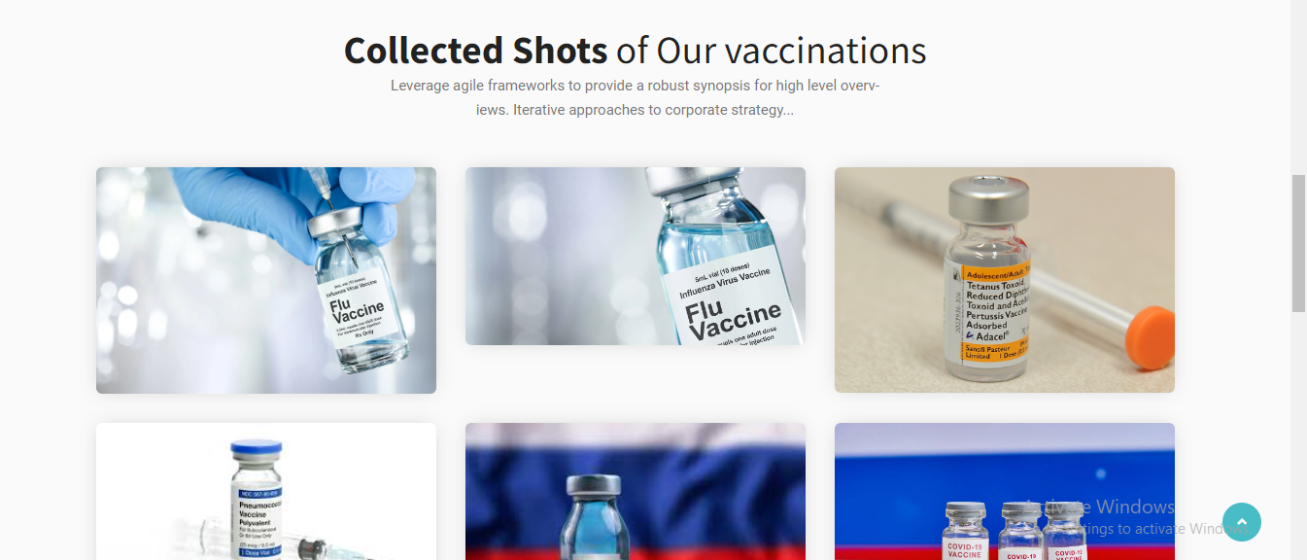

**Snapshots of Dashboard;**





                            
                            
                            
               